Active X Control Vendors

Co. Name | Web Page | Active X Controls Featured | Price |  | Demo Dowloaded?
Component Distributors:
 | www.componentsource.com
 | www.qbss.com
 | www.halogram.com
Specific Component Vendors
Infragistics | http://www.infragistics.com/ | Calendar, | $399 | View sample | yes
Netronic | http://www.netronic.de/index_eng.htm | Gantt Chart (really nice!!!) | ??? | View sample | yes
ProWorks | http://www.proworks.com/ | Nice 3-d charts, drafting controls | $350 | View sample | no
softel | http://www.softelvdm.com/cgibin/store/dlfile.cgi?PROD=treeocx&ID=279747774 | Hierarchy treeview w/ columns
GigaSoft | http://www.gigasoft.com/ | A ton of different charts available | $550 |  | Yes
??? | http://www.componentsource.com/  (This is the mother of all ActiveX sites…)  Chart FX Client Server | Chart controls | $499 |  | Yes
 | http://www.componentsource.com/  (This is the mother of all ActiveX sites…)  Gantt Time Package  (Calendar & Scheduling Comps.) | Gant charts  - I don’t like the interface as much | $237
 | http://www.componentsource.com/  (This is the mother of all ActiveX sites…)  dgChart  (Charting & Graphing Comps.) | Charts  - this demo doesn’t seem to work | $190
AddSoft | http://www.addsoft.com/GanttOCX/GanttOCX.htm  looks like the company is now using QBSS to distribute their software- check out www.qbss.com, look for Gantt/OCX | Gantt chart – cheap, comes w/ source code (for examples only???)

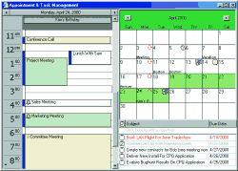
Infragistics Schedule X Composite Controls

Gantt Chart

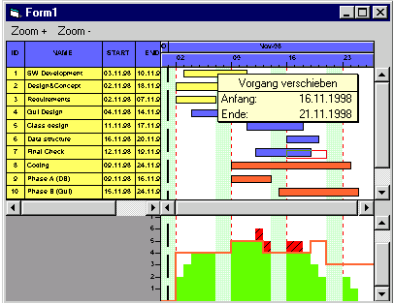
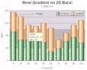
Chart Control (ProWorks)
